A

Progress Report

on

# Skin Cancer Detection Using Optimized Machine Learning Model

by

Afroj Ahmad (1900540100013)

Ajeet Yadav (19005401000016)

Ajit Priy Tripathi (1900540100017)

Aman Verma (1900540100028)

Under the Supervision of:

Mr. Ramesh Vaish

(Assistant Professor)

In Partial Fulfillment of the Requirements

for The Degree of

**Bachelor of Technology**

In

Computer Science & Engineering



Department of Computer Science & Engineering

**May, 2023**

### CERTIFICATE

This is to certify that **Afroj Ahmad** (1900540100013), **Ajeet Yadav** (1900540100001), **Ajit Priy Tripathi** (1900540100017), **Aman Verma** (1900540100028) ha**s** carried out the research work presented in the Report titled **“Skin Cancer Detection Using Optimized Machine Learning”** submitted for partial fulfillment for the award of the **Bachelor of Technology in Computer Science & Engineering** from **BBDITM, Lucknow** under my supervision.

It is also certified that:

1. This Report embodies the original work of the candidate and has not been earlier submitted elsewhere for the award of any degree/diploma/certificate.
2. The candidate has worked under my supervision for the prescribed period.
3. The Report fulfills the requirements of the norms and standards prescribed by the AKTU and BBDITM, Lucknow, India.
4. No published work (figure, data, table etc.) has been reproduced in the Report without express permission of the copyright owner(s).

Therefore, I deem this work fit and recommend for submission for the award of the aforesaid degree.

### Mr. Ramesh Vaish Dr. Anurag Tiwari

Project Guide H.O.D.

(Assistant Professor) Department of CSE,

Department of CSE, BBDITM, Lucknow

BBDITM, Lucknow

Date:12/05/2023

Place: Lucknow

### DECLARATION

We hereby declare that the Report titled **“Skin Cancer Detection Using Optimized Machine Learning”** is an authentic record of the research work carried out by me under the supervision of **Mr. Ramesh Vaish**, Department of Computer Science & Engineering, for the period from **August 2022** to **May 2023** at BBDITM, Lucknow. No part of this Report has been presented elsewhere for any other degree or diploma earlier.

We declare that we have faithfully acknowledged and referred to the works of other researchers wherever their published works have been cited in the Report. We further certify that I have not willfully taken other's work, para, text, data, results, tables, figures etc. reported in the journals, books, magazines, reports, Report, theses, etc., or available at web-sites without their permission, and have not included those in this B.Tech Report citing as my own work.

Date: 12/05/2023

(Signature)

* 1. Afroj Ahmad 1900540100013
  2. Ajeet Yadav

1900540100016

* 1. Ajit Priy Tripathi

1900540100017

* 1. Aman Verma

1900540100028

**ACKNOWLEGE MENT**

It gives us a great sense of pleasure to present the report of the B. Tech Project undertaken during B. Tech. Final Year. We owe special debt of gratitude to Mr. Ramesh Vaish Assistant Professor and Dr. Anurag Tiwari (Head, Department of Computer Science and Engineering) Babu Banarasi Das Institute of Technology and Management, Lucknow for their constant support and guidance throughout the course of our work. Their sincerity, thoroughness and perseverance have been a constant source of inspiration for us. It is only their cognizant efforts that our endeavors have seen light of the day. We also do not like to miss the opportunity to acknowledge the contribution of all faculty members of the department for their kind assistance and cooperation during the development of our project. Last but not the least, we acknowledge our family and friends for their contribution in the completion of the project.

List of Tables

|  |  |  |
| --- | --- | --- |
| **Table No** | **Table Caption** | **Page No** |
| 4.1 | Hardware and Software Specifications | 15 |

List of Figures

|  |  |  |
| --- | --- | --- |
| **Figure No** | **Figure Caption** | **Page No** |
| 1 | Image of different type of skin Cancer | 2-3 |
| 2 | Flow chart of the Proposed Methodology | 11 |
| 3 | Segmentation Image | 10 |
| 4 | Sigmoid Function Graphical Representation | 14 |
| 5 | Schematic Diagram of SVM | 15 |
| 6 | Random Forest schematic diagram | 16 |
| 7 | Layers of Convolutional Neural Network | 17 |

**TABLE OF CONTENTS**

|  |  |
| --- | --- |
| **Contents** | **Page No.** |
| **Title Page** | (i) |
| **Certificate/s(Supervisors)** | (ii) |
| **Declaration** | (iii) |
| **List of Tables** | (iv) |
| **List of Figures** | (v) |
| **Abstract** | (vii) |
| **1. Introduction** | 1-3 |
| **2. Literature Review** | 4-6 |
| **3. Proposed Work** | 7-14 |
| * 1. Problem Statement   2. Proposed Approach | 7  8-14 |
| **4. Hardware and Software Specification** | 15 |
| **5. Progress Work Details** | 16 |
| **6. Conclusion and Future Work** | 17 |
| * 1. Conclusion   2. Future Work | 17  17 |
| **References** | 18-19 |

# ABSTRACT

Skin cancer is one of the most dangerous forms of cancer. Skin cancer is caused by un-repaired deoxyribonucleic acid (DNA) in skin cells, which generate genetic defects or mutations on the skin. Skin cancer tends to gradually spread over other body parts, so it is more curable in initial stages, which is why it is best detected at early stages. The increasing rate of skin cancer cases, high mortality rate, and expensive medical treatment require that its symptoms be diagnosed early. For early detection, a dependable automated system for skin lesion recognition is absolutely mandatory in order to minimize effort, time and human life. This paper proposed a skin cancer detection model using image processing and different machine learning method comparing and which works best will be implemented. In this paper We tested combinations of models, including convolutional neural networks (CNNs), and various layers of data manipulation such as the application of Gaussian functions and trimming of images to improve accuracy. We also created more traditional data models, including support vector classification, Random Forrest, Logistic Regression and compared them to the CNN-based models.

.,

# CHAPTER 1

# INTRODUCTION

Skin cancer is the uncontrollable growth of damaged cells in the outer most layer of the skin. This is because of damage in DNA sequence due to the environmental factors like cigarette smoke and exposure to Ultra Violet (UV) light. DNA damage triggers mutation which leads to rapid multiplication of skin cells that forms malignant tumors [Miller .et. al. (1994)].

Skin cancer is classified into Melanoma, Basal Cell Carcinoma (BCC) and Squamous Cell Carcinoma (SCC). Melanoma is the most dangerous type of cancer which leads to death that usually appears on the moles and the areas on the skin which is exposed to sunlight as well as not exposed to sunlight. The affected part of the skin contains melanocytes that spread to other parts of the body. BCC is the most laggard growing and never be large in size. It appears on the skin exposed areas such as hand, face, leg, ears and scalp. It usually matures as an ulcer and does not improve. The early detection of this can be curable. Some are hostile and cannot be treated because it spreads to the deeper cells of the tissue. SQC appears on the sun exposed part and on the incurable inflammation part of the body and occurs in the person who has low immune power. It is large, appears in incurable scars and in lips. The early detection is possible.

Benign is a non-cancerous which does not spread to any other parts of the body. It is caused due to exposure of sunlight, inflammation of skin, infections, and genetics.

Melanoma mostly occurs in the skin rarely in the mouth and intestines with the abnormal cells that contain melanocytes which control the pigment in our skin. For women, melanoma mostly occurs on the legs and for men on the back. They usually develop from the mole with abnormal changes as an increase in size, changes in the color, causes itches or skin breakdown. It can occur in the areas between fingernails, palms, toenails and eyes [Miller .et. al. (1994)]. Benign usually appears on the skin which is highly exposed to sunlight such as face, shoulders, neck, hand and leg. This appears as lump and looks like patches which continues after a week and develops expert knowledge and experience. It is a very laborious and time-consuming procedure.

Skin cancer is the common type of cancer in worldwide and especially in US. By the age of 70, skin cancer will be developed by 1 in 5 Americans. In every hour, more than 2 people die because of skin cancer. Risk for melanoma will be doubled while exposure of sunburns is more than 5 in number. Early detection helps to survive for 5 years and the survival rate is 99 percent. At least 40% of cases have skin cancer when globally accounting for common cancer. Non-melanoma skin cancer occurs 2 to 3 million people per year. Globally in 2012, 232,000 people were in skin cancer, and 55,000 people died. According to the survey of last 20 to 40 years, Australia (white people), New Zealand and South Africa People have the highest rate of Skin cancer in the world [Apalla, Z.et. al. (2017)].

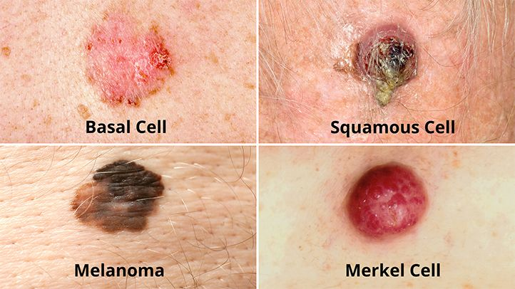

Figure 1:Four main type of skin cancer

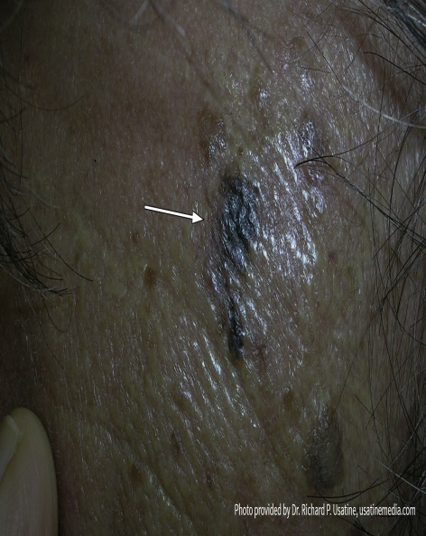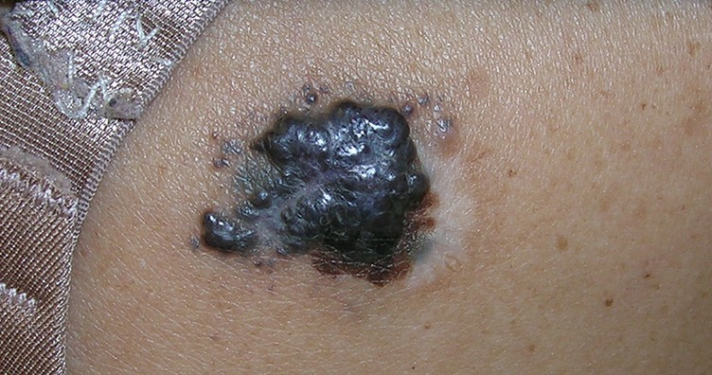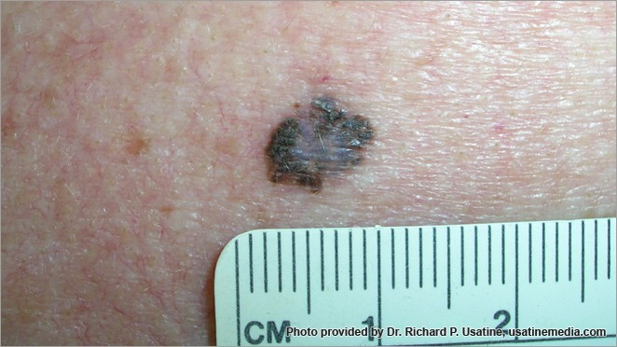

* + 1. (b) (c)

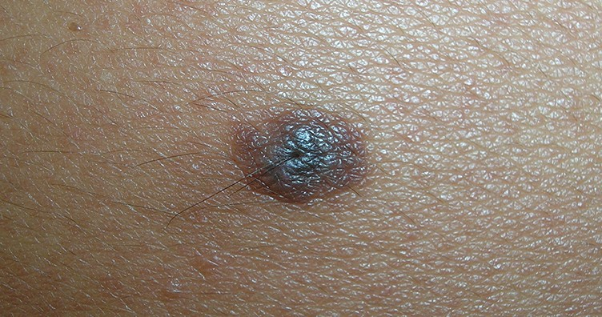

z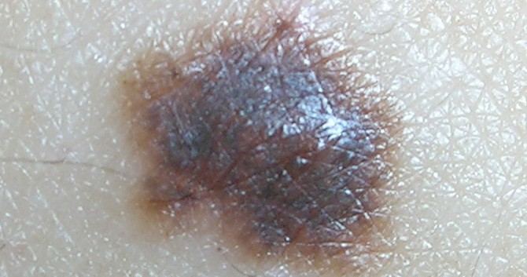 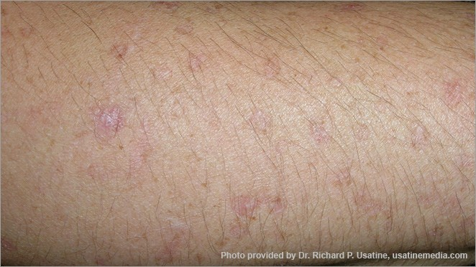

(d) (e) (f)

Figure 2: Images of Skin Cancer; (a) Melanoma (b)Melanoma; (c)Melanoma (d) Irregular mole (e) Irregular Mole (f)Irregular skin spot [13

# CHAPTER 2

# LITERATURE REVIEW

There have been related works done in the past to detect skin diseases using machine learning and deep learning. Aleem et al. published an article introducing a mobile-enabled cancer detection system for early. melanoma skin cancer using a support vector machine (SVM). The proposed system can be identiﬁed as three main steps: preprocessing, segmentation, and classiﬁcation. In the preprocessing step, image quality was improved by removing noise using the Gaussian function. In the segmentation step, the grab cut technique was used to split the image. In the feature extraction and classiﬁcation step, meaningful features such as mean, standard deviation, and perimeter were extracted. They mainly choose histogram and ABCD features proposed by the ABCD rule The SVM algorithm was applied as a classification technique. SVM algorithm provides good classification results in real-time smartphones. Even though model has been only applied for skin melanoma, this application can be extended to other skin diseases (eczema and skin rashes). It sensitivity and specificity rates are 80% and 70%. However, it would be worthwhile to evaluate the proposed system whith a different algorithm such CNN.

Lenhardt et al. [2] proposed a KNN-based skin cancer detection system. The proposed system processed synchronous fluorescence spectra of melanoma, nevus, and normal skin samples for neural network training. A fluorescence spectrophotometer was used to measure the fluorescence spectra of the samples, whereas samples were collected from human patients immediately after surgical resection. The dimensionality of measured spectra was reduced with the PCA technique. Both KNN and ANN were trained, and their performance for melanoma detection was compared. On the test dataset, the classification error of KNN was 2–3%, while the classification error for ANN lay in the range of 3% to 4%.

A technique for the classification of four different types of skin lesion images was proposed by Dorj et al. [3]. A pre-trained deep CNN named AlexNet was used for feature extraction, after which error-correcting output coding SVM worked as a classifier. The proposed system produced the highest scores of the average sensitivity, specificity, and accuracy for SCC, actinic keratosis (AK), and BCC: 95.1%, 98.9%, and 94.17%, respectively.

A combination of self-organizing NN and radial basis function (RBF) neural network was proposed to diagnose three different types of skin cancer, such as BCC, melanoma, and SCC [4]. The proposed system extracted color, GLCM, and morphological features of lesion images, after which the classification model used those features as input. Furthermore, the classification performance of the proposed system was compared with k-nearest neighbor, ANN, and naïve-Bayes classifiers. The proposed system achieved 93.150685% accuracy while k-nearest neighbor showed 71.232877%, ANN showed 63.013699%, and naïve Bayes showed 56.164384% accuracy scores.

Another KNN-based automated skin cancer diagnostic system was proposed by Sajid et al. [5]. The proposed system employed a median filter as a noise removal technique. Then filtered images were segmented with a statistical region growing and merging technique. In this system, a collection of textual and statistical features was used. Statistical features were extracted from lesion images, whereas textual features were extracted from a curvelet domain. Finally, the proposed system classified the input images into cancerous or noncancerous with 98.3% accuracy. In this work, other classifiers such as SVM, BPN, and 3-layer NN were also implemented, and their performance was compared with the proposed system’s classification performance. SVM produced 91.1% accuracy, BPN showed 90.4% accuracy, 3-layer NN showed 90.5%, whereas the proposed system achieved the highest accuracy of 98.3% for skin cancer diagnosis.

Lequan et al. [6] proposed a very deep CNN for melanoma detection. A fully convolutional residual network (FCRN) having 16 residual blocks was used in the segmentation process to improve performance. The proposed technique used an average of both SVM and softmax classifier for classification. It showed 85.5% accuracy in melanoma classification with segmentation and 82.8% without segmentation.

DeVries and Ramachandram [7] proposed a multi-scale CNN using an inception v3 deep neural network that was trained on an ImageNet dataset. For skin cancer classification, the pre-trained inception v3 was further fined-tuned on two resolution scales of input lesion images: coarse-scale and finer scale. The coarse-scale was used to capture shape characteristics as well as overall contextual information of lesions. In contrast, the finer scale gathered textual detail of lesion for differentiation between various types of skin lesions.

Mahbod et al. [8] proposed a technique to extract deep features from various well-established and pre-trained deep CNNs for skin lesions classification. Pretrained AlexNet, ResNet-18 and VGG16 were used as deep-feature generators, then a multi-class SVM classifier was trained on these generated features. Finally, the classifier results were fused to perform classification. The proposed system was evaluated on the ISIC 2017 dataset and showed 97.55% and 83.83% area under the curve (AUC) performance for seborrheic keratosis (SK) and melanoma classification

Viswanatha Reddy Allugunti [9] “[A machine learning model for skin disease classification using convolution neural network](https://www.researchgate.net/profile/Viswanatha-Allugunti-2/publication/361228242_A_machine_learning_model_for_skin_disease_classification_using_convolution_neural_network/links/62a46284a3fe3e3df86dc1d0/A-machine-learning-model-for-skin-disease-classification-using-convolution-neural-network.pdf)” a Convolutional Neural Network (CNN) model for the diagnosis of skin cancer was created, constructed, and evaluated using a well-known melanoma dataset. His proposed method, which is a two-stage learning platform, has great-predicted accuracy at each stage, as demonstrated by its overall accuracy of 88.83 percent.

Aswin et al. [10] described a new method for skin cancer detection based on a genetic algorithm (GA) and ANN algorithms. Images were preprocessed for hair removal with medical imaging software named Dull-Rozar and region of interest (ROI) and were extracted with the Otsu thresholding method. Furthermore, the GLCM technique was employed to extract unique features of the segmented images. Subsequently, a hybrid ANN and GA classifier was used for the classification of lesion images into cancerous and noncancerous classes. The proposed system achieved an overall accuracy score of 88

# CHAPTER 3

# Proposed Work

## Problem Statement

Currently skin cancer is being detected by doctors by manually checking the pattern and area of affected area. Since this method is time consuming and is prone to human errors, many research has been conducted to detect skin cancer automatically. This is happened due to high speed processor and graphics and large amount available medical data.

Many detection developed in the past on skin cancer Detection using machine but they have done by using only one or maximum two algorithm for training and processing the image of skin cancer.

Therefore there is need to test the different-different types of machine learning algorithm to determine the skin cancer and compare them their accuracy ,specificity, precision and how much time it take to train and complexity of implementation.

## Proposed Approach

The aim of this project is to compare the different Machine Learning Algorithm- Support Vector Machin (SVM) , K Nearest Neighbor(KNN) , Logistic Regression and Convolutional Neural Network (CNN) and apply one to predict the skin cancer.

## Preprocessing

The Image rescaling was done on the dataset to normalize the pixel data, and it will improve the model accuracy and efficiency in pre-processing step. Image augmentation, such as changing the image size, image normalization, image rotation, image width shift range image height shift range, shear range, Gaussian noise, and converting blue, green, and red (BGR) image to lab, and BGR to some other formats, was carried out to have a better identification of malignant and benign masses.

BGR to some other formats, was carried out to have a better identification of malignant and benign masses

## Segmentation and Object Recognition

The objective of the skin lesion segmentation step is to find the border of the skin lesion. It is important that this step is performed accurately because many features used to assess the risk of melanoma are derived based on the lesion border. Our approach to finding the lesion border is a texture distinctiveness-based lesion segmentation.

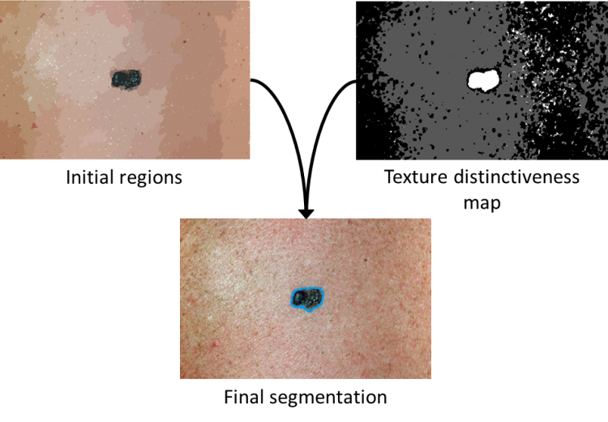

Figure3: segmentation

## Feature Extraction

The In order to use classification techniques, the image must be transformed such that it represented a point in some n-dimensional feature space. The axes in this feature space represent calculations that are relevant some n-dimensional feature space. The axes in this feature space represent calculations that are relevant to describing the observed phenomenon (e.g., malignancy).

**High-Level Intuitive Feature (HLIF**): A mathematical model that has been carefully designed to describe some human-observable characteristic, and whose score can be intuited in a natural way. In standard clinical practice, many dermatologists follow the ABCD rule for identifying melanoma. That is, for a given skin lesion, they attempt to identify Asymmetry (colour/structure), Border irregularity Color patterns, and Diameter. Our work involves modeling the ABC components of this analysis. Using the HLIF framework (Amelard 2013), these features are modeled such that intuitive diagnostic rationale can be given back to the doctor.

## Classification

Finally, classification of Skin Cancer can be determine which one is benign and which one is malignant present in images would be carried out using SVM , logistic regression , KNN and CNN and its performance evaluation will be evaluated by the confusion matrix.

## Proposed Design Methodology

## 

Figure 4: Flow chart of the Proposed Methodology

## Processing

Firstly, due to the variety of input image resolution, we perform proportional scale of each input image to the image with 600 pixels in width. We then propose to use three different preprocessing methods: Gaussian Blur, Normalization and combination of Gaussian Blur and Normalization.

**Gaussian Blur**

(GB) is a common way to reduce noise since the dataset images are collected from several sources. We use standard 5 × 5 Gaussian blur filter with σ = 1.1

Additionally, each dataset itself is collected from several sources, therefore its brightness and contrast should be normalized. We perform linear normalization (LN) to [0, 255] range for each pixel provided in each input image as follows:

n(x, y) = 255 ×{ i(x, y) / min max – min}

in which i(x, y) denotes the original input signal and n(x, y) denotes the corresponding normalized value.

In our experiments, we also use a combination of GB and LN to verify the effectiveness of this mixture toward Melanoma classification result.

## 3.3.2Feature Extraction

Many machine learning tasks require a feature selection step, reducing the number of dimensions from the feature space. It is mainly done by removing redundant, noisy and unimportant features. This step brings several benefits: reducing feature extraction time, reducing complexity for the next classification step, improving prediction results, reducing training and testing time. Each extracted feature is a vector representing an input image. We propose to use below features for different aspects of an input image.

1. **HSV (Hue-Saturation-Value**) represents the color features of the input image. We convert the input image (in RGB format) to HSV color space and calculate a 3D histogram for all channels (H, S, V), each divided into 8 bins. We then flatten this 3D histogram to achieve a color feature vector of 512 (= 8 × 8 × 8) dimensions.
2. **LBP (Local Binary Pattern)**: is a visual descriptor, representing textures of the input image. The input image is divided into 8×8 cells, each pixel in this cell is compared with its neighbor, providing a number for each pixel. We calculate the histogram of each cell, combine all together and perform normalization. The result is a 242-dimensional feature vector, representing textures of the input image
3. **HOG (Histogram of Oriented Gradients)** is another visual descriptor of an input image by counting gradient orientations of localized regions. The output of HOG is a shape feature vector composed of 65,520 dimensions.
4. **SIFT (Scale-Invariant Feature Transform)**: extracts key points of an input images, regardless of image transformation, scaling and rotation. The SIFT key points are then used for calculate the similarities of images.

Not only are the previous features assessed separately, we also evaluate the effectiveness when using them in combination.

Firstly we attempt to use the extracted features of HSV, LBP and HOG all together without transformation. Secondly, we evaluate their effectiveness of an additional linear normalization step after combination of them, e.g. HSV, LBP and HOG with normalization. Finally, an additional PCA (Principal Component Analysis) [12] is added after combining the 3 features, resulting in HSV, LBP and HOG with PCA, to evaluate the potency of dimension reduction.

To summarize, we use the following 7 feature extraction methods for evaluation of their effectiveness for Melanoma classification problem: HSV, LBP, HOG, SIFT, HSV+LBP+HOG, HSV+LBP+HOG with normalization, HSV+LBP+HOG with PCA.

## 3.3.3Classifier

The third step to solve the Melanoma classification problem is to perform classification, using the extracted features from previous step. This is a supervised learning task: for each image, its extracted features with their corresponding label (Melanoma or Benign) are fed to the classification model so that it can learn from the dataset. We evaluate the following 4 models for the Melanoma classification problem due to their popularity in good performance on various datasets:

* **LR (Logistic Regression)** is a common technique for solving binary classification problem. It uses a logistic function to model a binary dependent variable, then use this trained function to classify untrained data.

**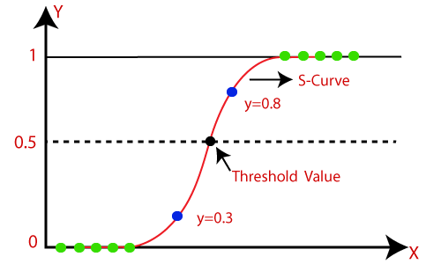**

Figure5: Logistic Regression Sigmoid Function

* **SVM(Support Vector Machine)**

The support vector machine SVM is a classifier that represents the training data as points in space separated into categories by a gap as wide as possible as depicted in the figure 7. New points are then added to the respective space in the training set by predicting which category they fall into and which space they will belong to. The classification is done by the points with respect to the hyperplane as depicted in Eq. 6. It uses a subset of training points in the decision making functions which makes it memory efficient and is highly effective in high dimensional spaces. The only disadvantage with the support vector machine is that the algorithm does not directly provide probability estimates.

Figure 6: Schematic Diagram of SVM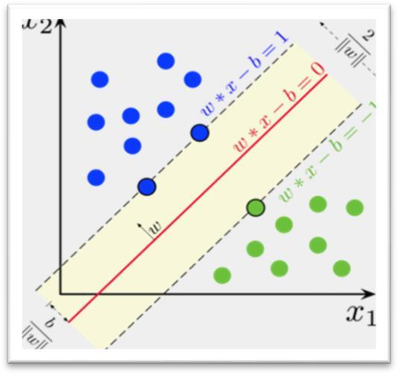

ℎ(𝑥) = {+1 𝑖𝑓 𝑤. 𝑥 + 𝑏 ≥ 0

−1 𝑖𝑓 𝑤. 𝑥 + 𝑏 < 0

where, w, x and b are the coefficients of the hyperplane equation

* **RF (Random Forest) :**

Random forest is a classification technique that leverage usage of multiple decision trees, each contains leaves representing class labels and branches representing conjunctions of features that lead to those labels. The trained decision trees are then used in a randomized fashion (therefore called Random Forest, in an attempt to overcome over-fitting nature of decision trees) to classify an untrained data.

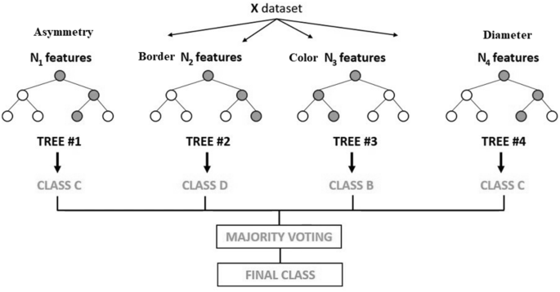

Figure 7 : Random forest Schematic Diagram

### CNN

Convolutional neural networks (CNN) is a special architecture of artificial neural networks and is a part of Deep Learning algorithms. One of the most popular uses of this algorithm is image classification. The image is passed through a series of various layers i.e. convolutional, nonlinear, pooling layers and fully connected layers, and then generates the output as depicted in figure 8. The algorithm selects a smaller array in the convolutional layer, which is called a filter. Then the filter performs convolution, i.e. moves along with the input image. The filter’s sole task is to multiply its values by the original pixel values of the images followed by summing these values. One number is obtained in the end. Since the filter has read the image only in the upper left corner, it moves further and further right by one unit performing the same operation. After passing the filter across all positions, an array is obtained, but smaller then a input array. After completion of series of convolutional, nonlinear and pooling layers, it is necessary to attach a fully connected

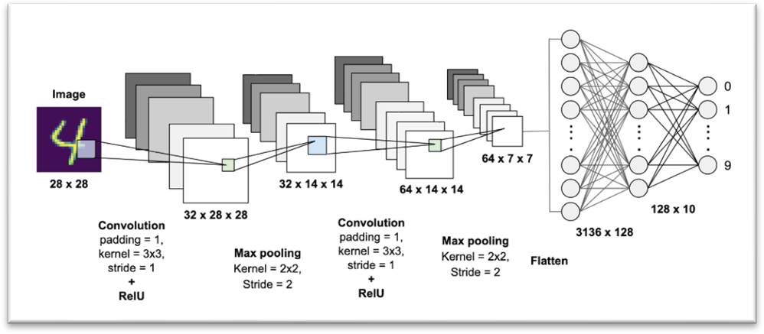layer because this layer takes the output information from convolutional networks.

Figure 8: Layers of Convolutional Neural Network .

### Accuracy is measured as the ability to differentiate the Melanoma and benign cases correctly.

**Accuracy =** (TP+TN**) /** (TP+TN+FN+FP)

**Sensitivity** is measured as the ability to determine the Melanoma cases correctly.

**Sensitivity=** TP **/** (TP+FN)

**Specificity** is measured as the ability to determine the benign cases correctly.

**Specificity =** TN / (TN+FP)

Where TN =True Negative, TP = True Positive, FN = False Negative, FP = False Positive

# CHAPTER 4

# Hardware and Software Specification

Processor –

Minimum: Any Intel or AMD x86-64 Processor.

Recommended: Any Intel or AMD x86-64 processor with

Four logical cores and AVX2 instruction set support.

Operating System –

Windows 10

Windows 11

Linux (Ubuntu 16.10 or above)

Disk-

Minimum: 3 GB for installation of Anaconda or other coding environment

Package and other libraries. 5-10 GB needed for total installation.

RAM-

Minimum: 4 GB RAM

Recommended: 8 GB or above.

Graphics-

No specific Graphics Card needed

For training large dataset graphics needed Hardware

accelerated graphics card supporting OpenGL 3.3 with 1 GB GPU

memory is accepted

Development Environment –

Anaconda (Virtual development environment)

Jupypter Notebook

VS code

Libraries-

Numpy

Panda

Matlplotlib

Scikit

Tensorflow

# CHPATER 5

# Progress Work Detail

* Studied different papers on the topic of Skin Cancer Detection using ML
* Literature survey of previous papers
* Melanoma Skin Cancer labeled database has been acquired
* Studied about NumPy library
* Studied about panda library
* Studied about Scikit library

**Working on Convolutional Neural Network model:**

We have trained a model on HAM-10000 data which is available on Kaggle platform. The model trained on HAM-100000 data run 40 epoch and produce accuracy around 79%.HAM-10000 data unbalanced so the accuracy is low it can be improved by cleaning balancing The data.

Here is the screen shot of the model:

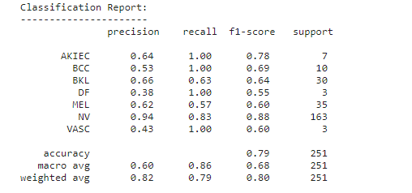

# CHAPTER 6

# Conclusion & Future Work

## Conclusion

In the discipline of dermatology, AI and Machine learning is quickly gaining traction. It has the potential to transform patient care, especially in terms of enhancing the sensitivity and accuracy of screening for skin lesions, including cancer.

Based upon the results observed in the comparison of these models, it appears that using any of the implementations we created using a convolutional neural network model of machine learning has a significant improvement in accuracy the largest limitation of the works we have created is due primarily to the limited size of the dataset that was used.

## Future Work

The most important purpose of work is to compare the exiting machine learning algorihm and compare them which one work best for skin cancer detection. the model above we have studied can be use to implement on mobile devices because some of the model are light weight and fast to train and some are more accurate than the other but not light. and this model can also be improve by inclusion of larger dataset because the largest drawback of these models are the limited dataset.

# References

1. M. A taufiq , N Hameed , A Anjum and F. Hameed “ M-skin Doctor : a mobile enabled system for early melanoma skin detection using support vector machine ” *E Health 360°*, Springer International Publishing, New York, NY, USA, pp. 468–475, 2017.
2. Lenhardt L., Zeković I., Dramićanin T., Dramićanin M.D. Artificial Neural Networks for Processing Fluorescence Spectroscopy Data in Skin Cancer Diagnostics. *Phys. Scr.*2013;**T157**:014057. doi: 10.1088/0031-8949/2013/T157/014057. [[CrossRef](https://doi.org/10.1088%2F0031-8949%2F2013%2FT157%2F014057" \t "_blank)] [[Google Scholar](https://scholar.google.com/scholar_lookup?journal=Phys.+Scr.&title=Artificial+Neural+Networks+for+Processing+Fluorescence+Spectroscopy+Data+in+Skin+Cancer+Diagnostics&author=L.+Lenhardt&author=I.+Zekovi%C4%87&author=T.+Drami%C4%87anin&author=M.D.+Drami%C4%87anin&volume=T157&publication_year=2013&pages=014057&doi=10.1088/0031-8949/2013/T157/014057&)]
3. Dorj U.-O., Lee K.-K., Choi J.-Y., Lee M. The Skin Cancer Classification Using Deep Convolutional Neural Network. *Multimed. Tools Appl.*2018;**77**:9909–9924. doi: 10.1007/s11042-018-5714-1. [[CrossRef](https://doi.org/10.1007%2Fs11042-018-5714-1" \t "_blank)] [[Google Scholar](https://scholar.google.com/scholar_lookup?journal=Multimed.+Tools+Appl.&title=The+Skin+Cancer+Classification+Using+Deep+Convolutional+Neural+Network&author=U.-O.+Dorj&author=K.-K.+Lee&author=J.-Y.+Choi&author=M.+Lee&volume=77&publication_year=2018&pages=9909-9924&doi=10.1007/s11042-018-5714-1&)]
4. Mengistu A.D., Alemayehu D.M. Computer Vision for Skin Cancer Diagnosis and Recognition Using RBF and SOM. *Int. J. Image Process.*2015;**9**:311–319. [[Google Scholar](https://scholar.google.com/scholar_lookup?journal=Int.+J.+Image+Process.&title=Computer+Vision+for+Skin+Cancer+Diagnosis+and+Recognition+Using+RBF+and+SOM&author=A.D.+Mengistu&author=D.M.+Alemayehu&volume=9&publication_year=2015&pages=311-319&)]
5. Sajid P.M., Rajesh D.A. Performance Evaluation of Classifiers for Automatic Early Detection of Skin Cancer. *J. Adv. Res. Dyn. Control. Syst.*2018;**10**:454–461. [[Google Scholar](https://scholar.google.com/scholar_lookup?journal=J.+Adv.+Res.+Dyn.+Control.+Syst.&title=Performance+Evaluation+of+Classifiers+for+Automatic+Early+Detection+of+Skin+Cancer&author=P.M.+Sajid&author=D.A.+Rajesh&volume=10&publication_year=2018&pages=454-461&)]
6. Yu L., Chen H., Dou Q., Qin J., Heng P.-A. Automated Melanoma Recognition in Dermoscopy Images via Very Deep Residual Networks. *IEEE Trans. Med. Imaging.*2017;**36**:994–1004. doi: 10.1109/TMI.2016.2642839. [[PubMed](https://pubmed.ncbi.nlm.nih.gov/28026754)] [[CrossRef](https://doi.org/10.1109%2FTMI.2016.2642839" \t "_blank)] [[Google Scholar](https://scholar.google.com/scholar_lookup?journal=IEEE+Trans.+Med.+Imaging&title=Automated+Melanoma+Recognition+in+Dermoscopy+Images+via+Very+Deep+Residual+Networks&author=L.+Yu&author=H.+Chen&author=Q.+Dou&author=J.+Qin&author=P.-A.+Heng&volume=36&publication_year=2017&pages=994-1004&pmid=28026754&doi=10.1109/TMI.2016.2642839&)]
7. DeVries T., Ramachandram D. Skin Lesion Classification Using Deep Multi-Scale Convolutional Neural Networks. [(accessed on 13 February 2021)];*arXiv.*2017 Available
8. Mahbod A., Schaefer G., Wang C., Ecker R., Ellinge I. Skin Lesion Classification Using Hybrid Deep Neural Networks; Proceedings of the ICASSP 2019–2019 IEEE International Conference on Acoustics, Speech and Signal Processing (ICASSP); Brighton, UK. 12–17 May 2019; pp. 1229–1233. [[CrossRef](https://doi.org/10.1109%2FICASSP.2019.8683352" \t "_blank)] [[Google Scholar](https://scholar.google.com/scholar_lookup?journal=Proceedings+of+the+ICASSP+2019%E2%80%932019+IEEE+International+Conference+on+Acoustics,+Speech+and+Signal+Processing+(ICASSP)&title=Skin+Lesion+Classification+Using+Hybrid+Deep+Neural+Networks&author=A.+Mahbod&author=G.+Schaefer&author=C.+Wang&author=R.+Ecker&author=I.+Ellinge&pages=1229-1233&doi=10.1109/ICASSP.2019.8683352&)]
9. Viswanatha Reddy Allugunti “[A machine learning model for skin disease classification using convolution neural network](https://www.researchgate.net/profile/Viswanatha-Allugunti-2/publication/361228242_A_machine_learning_model_for_skin_disease_classification_using_convolution_neural_network/links/62a46284a3fe3e3df86dc1d0/A-machine-learning-model-for-skin-disease-classification-using-convolution-neural-network.pdf)” International Journal of Computing, Programming and Database Management,1, 141-147,vol 3 2022
10. Aswin R.B., Jaleel J.A., Salim S. Hybrid Genetic Algorithm: Artificial Neural Network Classifier for Skin Cancer Detection; Proceedings of the 2014 International Conference on Control, Instrumentation, Communication and Computational Technologies (ICCICCT); Kanyakumari, India. 10–11 July 2014; pp. 1304–1309. [[CrossRef](https://doi.org/10.1109%2FICCICCT.2014.6993162" \t "_blank)] [[Google Scholar](https://scholar.google.com/scholar_lookup?journal=Proceedings+of+the+2014+International+Conference+on+Control,+Instrumentation,+Communication+and+Computational+Technologies+(ICCICCT)&title=Hybrid+Genetic+Algorithm:+Artificial+Neural+Network+Classifier+for+Skin+Cancer+Detection&author=R.B.+Aswin&author=J.A.+Jaleel&author=S.+Salim&pages=1304-1309&doi=10.1109/ICCICCT.2014.6993162&)]
11. Skin Cancer example image are taken from cancer.org